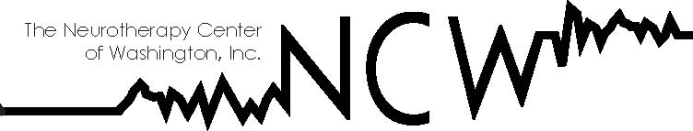

7920 Norfolk Ave. #200 Bethesda, MD 20814
Phone: 301-652-7175 Fax: 301-652-7186
www.neurotherapycenters.com

Neurotherapy for Chronic TBI/PTSD Symptoms in Vietnam Veterans.
The Journal of Head Trauma Rehabilitation. 2009 (24)5, 403.
Nelson, D and Esty, ML

Objectives:

We have previously demonstrated the potential of a novel form of neurotherapy that involves minute pulsed electromagnetic (EM) stimulation of brainwave activity for the amelioration of traumatic brain injury (TBI) and associated post-traumatic stress disorder (PTSD) symptoms in returning service personnel from the Afghanistan and Iraq wars. The purpose of this report is to summarize findings that suggest application of the same treatment protocol has the potential to provide the same kind of improvement in more long-standing, chronic conditions of mixed TBI and PTSD symptoms.

Method:

Two veterans with histories of very persistent and debilitating TBI and PTSD symptoms dating from their involvement in the Vietnam War were seen in 25 individual neurotherapy treatment sessions over 3 months. Each veteran was treated with an adaptation of the Flexyx Neurotherapy System (FNS) that uses very tiny, subliminal pulses of EM energy to stimulate changes in brainwave activity by adding a fixed amount of EM stimulation to the momentary peak EEG frequency at multiple electrode placement sites in a predetermined order. Symptom questionnaires and rating scales were completed at pre- and post-treatment, as well as individual symptom rating scales at each treatment session.

Results:

Both veterans experienced significant reductions in bothersome cognitive and affective/emotional symptoms, and improvements in energy level, sleep, and other aspects of psychosocial functioning from pre- to post-treatment. This corresponded with their spontaneously offered subjective reports of improvements in multiple domains of cognitive and emotional, as well as psychosocial functioning. FNS as adapted for use in this project appears to offer promise for potentially similar reduction of bothersome symptoms in chronic, complicated cases of mixed TBI/PTSD as has been previously demonstrated in persistent, though less chronic, conditions.

Error: Reference source not found



